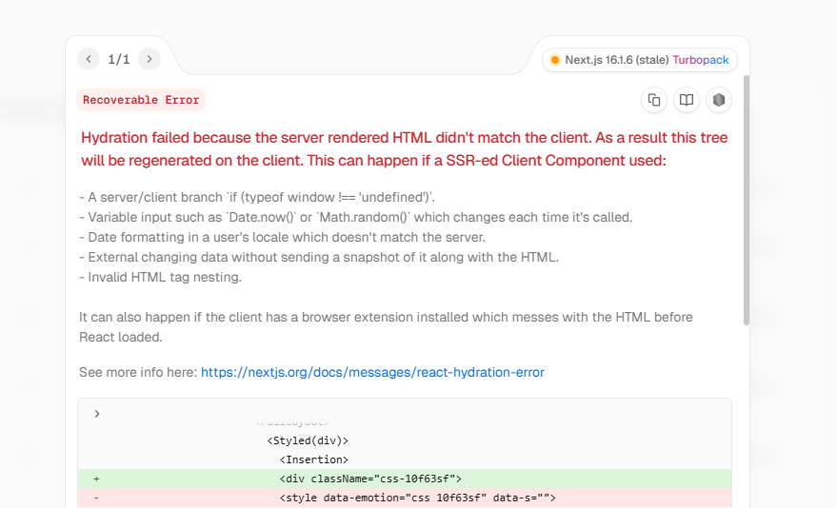
We get this error when we were using server component but when we use client component then no error is shown To solve this follow this chats
// "use client"
import AdminAllProducts from "@/components/AdminAllProducts"
const page = () => {
return (
<div>
<AdminAllProducts/>
</div>
)
}

export default page
This error is forsing us to make it a client but we put all the client code in the AdminAllProducts but still it is getting that error solve this
The issue is not this page component.
This page is perfectly fine as a Server Component:
const page = () => {
return (
<div>
<AdminAllProducts />
</div>
)
}
The real problem is inside your MUI setup.
From the error screenshot:
<style data-emotion="css ...">
this is Emotion/MUI hydration mismatch.
That means:
- server generated one className
- client generated another
- HTML differs
- hydration fails

This usually happens when:
- MUI ThemeProvider setup is incomplete
- Emotion cache/provider missing
- App Router MUI SSR setup not configured correctly
NOT because page must be client.

Most likely fix:
You are probably wrapping ThemeProvider incorrectly in random pages instead of root layout.
In App Router, MUI should usually be configured globally.

You need proper MUI App Router setup.
Typical structure:
app
├── layout.jsx
├── themeRegistry.jsx

Main fix:
Use:
npm install @mui/material-nextjs
Then setup:
AppRouterCacheProvider
in root layout.

Example root layout:
import { AppRouterCacheProvider } from '@mui/material-nextjs/v15-appRouter';

export default function RootLayout({ children }) {
return (
<html lang="en">
<body>
<AppRouterCacheProvider>
{children}
</AppRouterCacheProvider>
</body>
</html>
);
}
Without this, MUI + App Router commonly causes hydration mismatch.

Why "use client" seems to fix it:
Because then rendering happens only on client, avoiding SSR mismatch entirely.
But that is bypassing the actual issue, not solving it.
Why this error was happening in simple words that any novice can understand and in simple words
Simple meaning of this error:
When Next.js loads a page, it first creates HTML on the server, then React checks it again in browser.
Both outputs must match exactly.
But in your case:
Server HTML ≠ Browser HTML
So React says:
“The page I got from server is different from what browser created.”
That is hydration error.

In your case MUI/Emotion generated different CSS class names on:
- server
- browser
Example:
Server made:
<div class="css-abc123">
Browser made:
<div class="css-xyz999">
React compares them and gets confused.

Why "use client" hides the error:
Without SSR:
- server does not generate HTML
- browser creates everything itself
- no comparison happens
- therefore no mismatch
So:
No server HTML → no hydration mismatch

Think of hydration like this:
- Server prepares page 🍱
- Browser prepares same page 🍱
- React compares both
If even small thing differs:
Hydration failed
what the solution you gave did(onelienr)
The solution makes MUI generate the exact same styles/classes on both server and browser so hydration matches correctly.

